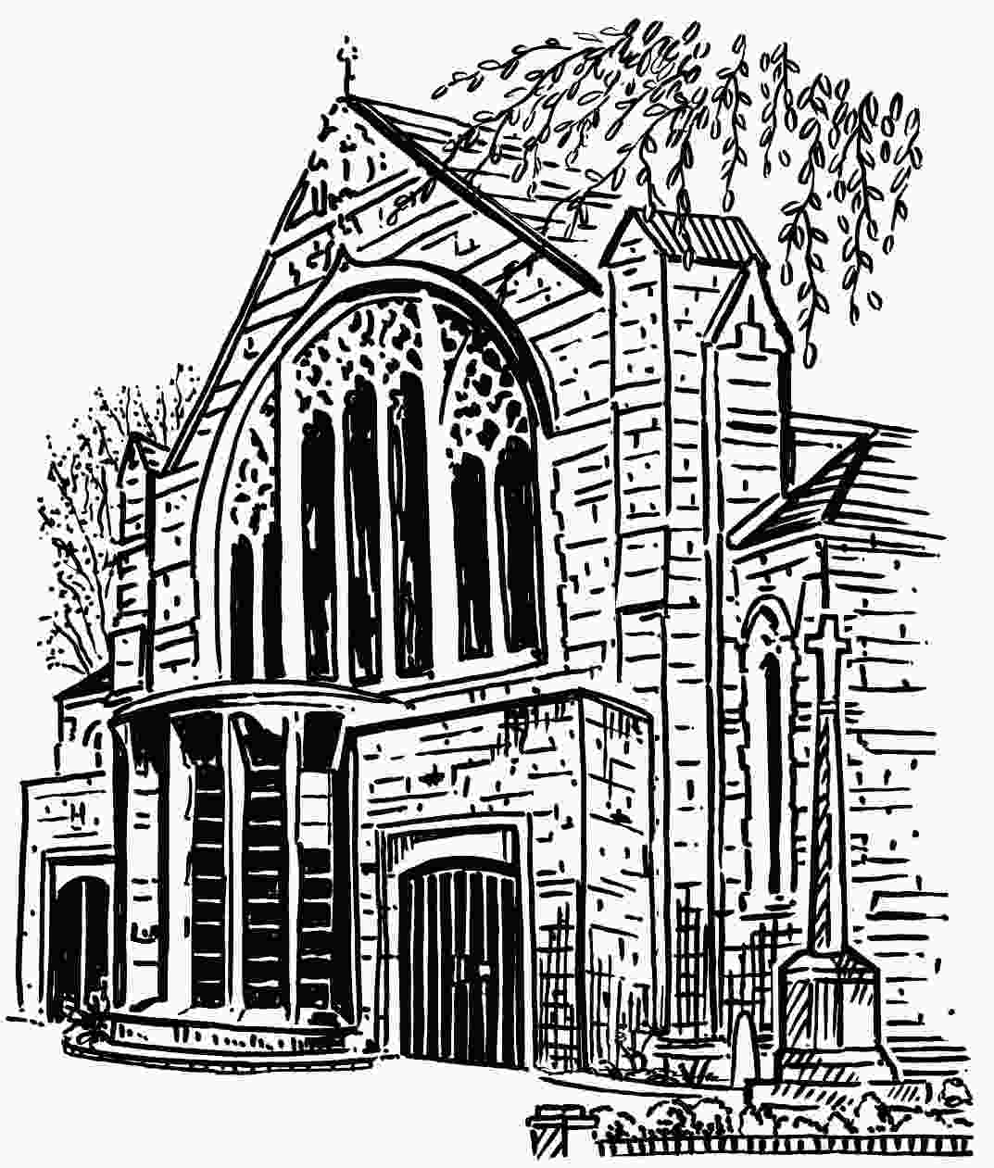
The Parish of St Martin with St Peter

London Road Worcester WR5 2ED

HEALTH & SAFETY

As the Parochial Church Council, we understand that we owe a duty of care to ensure the safety of those who visit or use our church, church grounds and Parish Centre.
We also know that, where we are an employer or control premises in certain circumstances, we have to meet the requirements of health and safety law.
This Health & Safety Policy has been written to meet our duty under Section 2(3) of the Health and Safety at Work etc. Act 1974.

General statement of policy

Our policy is to ensure, so far as is reasonably practicable, that our activities are carried out safely and do not pose a risk to the health of our employees, contractors, volunteers, worshippers, visitors and members of the public who may use the church, churchyard or any other building we are responsible for. This will be in accordance with good practice and any relevant statutory provisions where they apply.
The Parochial Church Council (PCC) accepts its ultimate responsibility for meeting this objective, and will ensure that adequate resources are made available. Any decisions we make will have due regard for it.
We will appoint a member of the PCC to have specific responsibility for this policy and its implementation. We will keep health and safety matters under review at appropriate intervals. We will monitor the effectiveness of the policy, amending it where we believe it is no longer valid.
It is the duty of each employee, contractor, and all persons who use the church to exercise personal responsibility for their own safety and that of others. This policy will be brought to their attention. We will try to ensure that everyone involved with the church plays his or her part in its implementation.
Further detail about our organisation and arrangements for managing health and safety is set out in this document. A copy of it will be kept in the church and made available to others on request.

Policy adopted at Parochial Church Council meeting on 11th September 2018.
Reviewed at Parochial Church Council meeting on 12thOctober 2021.

Organisation and Responsibilities
(See Appendix A for specific responsibilities)
- The PCC member with overall responsibility for implementing our policy is (see Appendix A)
They will ensure that:
- The standards set out in this policy are implemented and maintained
- Where necessary, specialist health and safety assistance is obtained
- Any hazards reported to them are rectified immediately
- Only competent persons carry out repairs, modifications, inspections and tests
- Any accidents are investigated, recorded and reported if necessary
- Relevant health and safety documents and records are retained
- They keep up to date on health and safety matters relevant to the church
- They set a personal example on matters of health and safety
- The Churchwardens have day-to-day responsibility for implementing our policy.
They will ensure that:
- All employees, contractors and volunteers are aware of their health and safety responsibilities
- Adequate precautions are taken as set out in this policy and related risk assessments
- Adequate information and training is provided for those that need it
- Appropriate safety and personal protective equipment is provided
- Any hazards or complaints are investigated and dealt with as soon as possible
- Where defects cannot be corrected immediately, interim steps are taken to prevent danger
- All accidents are recorded in-line with the requirements of this policy
- Advice is sought where clarification is necessary on the implementation of this policy
- They set a personal example on matters of health and safety
- All employees, contractors, church members, volunteers and Parish Centre users have a responsibility to cooperate in the implementation of this policy and to take reasonable care of themselves and others while on church business or premises.
They will ensure that, if appropriate, they:
- Read this policy and understand what is required of them
- Complete their work taking any necessary precautions to protect themselves and others
- Comply with any safety rules, operating instructions and other working procedures
- Use personal protective clothing and equipment when required
- Report any hazard, defect or damage, so that this might be dealt with
- Warn any new employees, contractors or volunteers of known hazards
- Attend any training required to enable them to carry out their duties safely
- Do not undertake any repair or modification unless they are competent to do so
- Report any accident
- Do not misuse anything provided in the interests of health and safety.

Arrangements
This section sets out our general arrangements for managing health and safety and dealing with specific risks.
General Arrangements
Competent Assistance
Where necessary, we will assign a competent person to assist us in meeting our health and safety obligations.
Responsible persons(see Appendix A for Specific Responsibilities)
The following are responsible for health and safety for events in the church:
- Churchwardens, Deputy Churchwardens & Sidespersons for all church services.
- Leaders for activities e.g. Mainly Music, Messy Church, Tunes & Chips, Tiny Tunes.
- Organisers of concerts, social events, etc.
- Others as appointed for particular events.
Risk Assessment
We will complete risk assessments to identify what we need to do to comply with health and safety law. We will record our findings, implementing any necessary precautions. We will review and revise these where we suspect that they are no longer valid.
Information and Training
We will provide any necessary information and training for our employees, contractors and volunteers in a timely manner. We will keep a record of what is provided. We will also give relevant information to contractors and self-employed people who may need this to complete their work safely.
First Aid
We will provide adequate first aid facilities including suitably stocked first aid boxes and appoint a First Aid Co-ordinator to co-ordinate our first aid arrangements. We will also provide relevant information for employees and volunteers.
Our first aid boxes are located in the Team Office, Lower Vestry, Sacristy, North Aisle & Kitchen.
Accident Reporting
We will keep an accident book in the Team Office and record details therein. We will report to the enforcing authority and keep records of certain accidents to employees, contractors, volunteers and members of the public in accordance with the Reporting of Injuries, Diseases and Dangerous Occurrences Regulations (RIDDOR) (see Appendix D.)
Outside organisations using the church or the Parish Centre are required to report accidents and record details in the accident book – a separate book is kept in the Team Office for this purpose.
Monitoring
We will make periodic checks to ensure that our precautions remain effective and adequate. We will also ensure that any lifting, works, electrical installations, and church fixtures and fittings are inspected as necessary to ensure that they remain safe. We will keep records of the checks we make.
Contractors(see Appendix B)
If we employ contractors, they shall be provided with a copy of this policy, and we shall make sure that they have their own health & safety policy and public and Employers Liability Insurance by asking to see copies of the relevant documents.
Record Keeping
Our Health and Safety Risk Assessments, records, and other documents, are kept in the Team Office.

Specific Arrangements
Working Alone
Any person working alone must comply with the St Martin’s Lone Worker Policy to ensure their safety.
Asbestos
We have taken steps to establish the absence of asbestos in the church and the Parish Centre.
If, however, any asbestos is identified, we will assess any risk from it. We will then implement any plan to manage that risk. We will also provide relevant information to others who might need it (for example, building contractors). We will keep records of the checks, assessments and plans we have made.
Church Buildings
We will ensure that the fabric of our buildings is regularly inspected to make sure it is safe. Defects will be repaired as soon as is practicable bearing in mind that a faculty may be required. Where necessary, temporary measures will be taken to prevent danger until permanent repairs can be made. This will include glazing.
Church Grounds
We will ensure that boundary walls, gates, pathways and steps are kept in good repair. Trees will be inspected by a competent person and we will have any necessary work carried out to make them safe. Monuments will be checked regularly to ensure they are properly maintained.
We will have arrangements in place to manage pathways in winter weather.
Slips and Trips
We will implement suitable precautions to prevent slips or trips, taking account of any difficulty the frail, elderly or disabled may have in negotiating access. We will make periodic checks to ensure that floors, coverings and steps remain in good condition and free from obstructions, and that any precautions (such as hand rails or lighting) remain adequate. We will correct any defects identified, keeping records of the checks we make.
Display Screen Equipment
Where our employees and volunteers regularly use computers daily, for continuous periods of an hour or more, we will risk assess workstations to identify precautions, implementing these as necessary. We will also provide information, training, eye/eyesight tests (on request) and special spectacles if needed.
Events
Where we intend to hold large or unusual concerts, services and fundraising events, we will identify and implement any additional precautions that are necessary.
Preparation and Serving of Food
The requirements of The Food Safety Act 1990 and The Food Safety and Hygiene (England) Regulations 2013 will be complied with. We will ensure that on those occasions when we prepare food, we use a clean and disinfected work surfaces, utensils and equipment. We will store food in such a way as to avoid contamination, provide hand-washing facilities and suitable arrangements for the disposal of waste.
Only those who have received training shall prepare and serve food (see Appendix A).

Hazardous Substances
We only use domestic cleaning or horticultural products and petrol. We will ensure that these are stored, used and disposed of in accordance with the manufacturers’ product information and/or safety data sheets, taking any necessary precautions that are specified.
Copies of product information and safety data sheets for all hazardous substances used are kept in the Team Office. Those using such products shall read and observe the information provided and wear the provided protective clothing as required.
Electricity and Lighting
We will ensure that, in accordance with The Electricity at Work Regulations, any electrical systems are constructed, maintained and used in such a manner as to prevent danger. We will ensure that electrical systems are inspected, tested and checked, and keep records as required(see Appendix C).
Any handheld equipment shall be inspected before use and any defective equipment will not be used until it is repaired or replaced.
Failed luminaires will be replaced promptly to ensure adequate lighting is maintained.
Emergency lighting will be tested regularly (see Fire and Evacuation Procedure).
Heating Systems
We will ensure that our gas heating system is suitably maintained and checked and tested annually by a competent person. Any defects found will be corrected immediately and we will keep records of the checks made. The carbon monoxide detector in the boiler room shall be tested each quarter.
Fire(see Fire and Evacuation Procedure).
We will complete a specific risk assessment to identify what steps are necessary to prevent, detect and take in the event of a fire.
Adequate fire detection and firefighting equipment will be provided, and regularly maintained as required.
Manual Handling
We will avoid the need for lifting or carrying heavy objects as far as is possible. Where this is not practical, we will make use of lifting aids (such as, trolleys) or other precautions including team lifting.
Lifting Equipment
We will ensure that any lifting equipment is properly maintained and thoroughly examined periodically by a competent person.
Working at Height
Where possible we will try and avoid the need for work at height. Where this is not practicable, we will ensure that any work is properly planned to identify suitable precautions. We will make sure that these are implemented, including the provision of suitable equipment and training and checks to ensure the safety of any equipment used.
Plant, Machinery, Equipment& Tools
Any work equipment we provide will be suitable, in good condition and properly maintained. Appropriate training will be provided where necessary. Equipment (such as, ladders) will be regularly checked to make sure they are safe. We will keep records of any checks we make.
Construction Work
Where maintenance, refurbishment and restoration work is planned for our church or the Parish Centre, we will identify what we need to do to ensure the safety of all those concerned before work starts. We will also determine if we have any responsibilities under the Construction (Design and Management) Regulations and comply with these if necessary.
Appendix A
Specific Responsibilities

PCC member with overall responsibility for implementing our policy: Malcolm McMurray
Churchwardens with day-to-day responsibility for implementing our policy: Elizabeth Yarker
Joy Grimwood
The appointed competent person (to provide H&S advice): (will be appointed as and when required)
Safeguarding of children and vulnerable adults (see Safeguarding Policy): Safeguarding Officer – Malcolm McMurray

By Activity
- Health and safety training – where necessary, Churchwardens.
- First Aid Co-ordinator: Barbara Richards
- Trained First Aiders: Julia Glossop, Joy Grimwood, Joan Hazzard, Isobel Maher, Barbara Richards, Shirley Scott.
- Clerk of Works: David Hall.
- Condition of floors and stairs: Church - David Hall & Cleaner.
Parish Centre - Malcolm McMurray.
- Condition of church grounds: Bill Simpson.
- Preparation of food: Alison Fraser (co-ordinator), Julia Glossop, Isobel Maher, David Scott, Shirley Scott, Elizabeth Yarker.
- Hazardous substances: David Hall/Malcolm McMurray.
- Electrical Systems and Appliances (see Appendix C): David Hall, Malcolm McMurray.
Office Computers: Garth Williams.
Audio visual equipment: Mark Farthing.
Sound systems: David Scott.
- Gas boiler and heating system: David Hall, Malcolm McMurray, David Scott.
- Plant and machinery, work equipment, tools and protective clothing: David Hall, Malcolm McMurray.
- Manual handling / Lifting equipment / Working at height: David Hall, Malcolm McMurray.
- Building defects/glazing/Contractors: David Hall.
- Choirs/Tunes & Chips/Music: John Swindells
- Messy Church/Mainly Music: Sheila Farthing
- Concerts/Tiny Tunes: David Scott, Shirley Scott

By area
- Main body of church, Chapels and Lower floor, inc. kitchens: Churchwardens, David Hall, Cleaner.
- Choir stalls and organ loft: Director of Music – John Swindells.
- Sacristy: Rector/Curate/Sacristan – Nick Harrison.
- Team Office: Team Administrator – Rebecca Caskie.
- Boiler room: David Hall.
- Church grounds: David Hall, Bill Simpson.
- Parish Centre: Malcolm McMurray, Joan Hazzard.

Appendix B
Contractors
Anyone entering church premises for the purposes of carrying out work, other than an employee or a member of the church, will be regarded as a contractor.
All contractors, including the self-employed, must:
- have their own health and safety policy (where required by law) and be able to provide a copy of the same.
- produce evidence that they have appropriate Public and Employers’ Liability insurance in place. A record of this evidence will be maintained.
- comply with all the requirements of this health and safety policy and co-operate with the church officials in providing a safe place of work and a safe system of operation.
- where plant and machinery is brought onto the church premises by contractors, they must be able to show where necessary that the equipment has been inspected and tested to ensure its safe operation.
- contractors may only use sub-contractors or persons other than their own direct employees with the express permission of the church officials. However, responsibility will remain with the contractors.
- all contractors will be given detailed instructions regarding the areas where they are permitted to work and the extent of the work they are authorised to undertake. This ‘permit to work’ will also specify any safety precautions they must undertake.
The Clerk of Works shall ensure:
- there are suitable management arrangements for the project including welfare facilities
- allow sufficient time and resources for all stages
- provide pre-construction information to designers and contractors.

Notes:
- The Construction (Design & Management) Regulations apply to all construction work in Great Britain.
- A project is notifiable to the HSE if the construction phase will be longer than 30 days or 500 person days of construction work, and for such projects, the church will appoint a CDM co-ordinator and a Principal contractor.

Appendix C
Electrical safety
Misuse and abuse of electricity is a significant cause of fires and injury. Faulty electrical equipment can kill.
All employees, contractors and volunteers must:
- Visually check all electrical equipment before use.
- Report all faults immediately to the responsible person or churchwarden.
- Not attempt to use or repair faulty equipment unless qualified to do so.
- Not bring electrical equipment onto the premises and use it unless it has been tested by a competent person and entered in the electrical appliance inventory.
- Switch off electrical equipment and disconnect it when not in use for long periods.
- Ensure that flexible cables and extension leads are positioned and protected so that they do not constitute a tripping hazard and are not subject to mechanical damage.

All electrical equipment shall be regularly inspected, tested and checked to ensure compliance with The Electricity at Work Regulations.
An inventory of all electrical equipment shall be maintained by the responsible person (see Appendix A).
The responsible person shall appoint a competent person to inspect and test handheld, portable and moveable appliances, and a competent contractor to inspect and test the fixed electrical system and lightning conductor system.
Handheld electrical equipment (drills, hedge trimmers, etc.) shall be user checked before use.
All portable (kettles, toasters, etc), moveable (water urns, etc) and stationary (fridges, cookers, etc.) electrical equipment, and I.T. equipment (computers and printers, etc.) shall be user checked each week.
Every four months plugs, cables extension leads and sockets shall be inspected by the responsible person to ensure that there are no loose connections, worn flexes or trailing leads. Any repairs needed shall be actioned.
Every year, All handheld, portable and moveable appliances, and I.T. equipment, shall be inspected and tested (PAT tested) with the appropriate test equipment, by a competent contractor with an appropriate level of electrical knowledge and experience to complete the tests and correctly interpret the results. Any unsafe equipment will be immediately withdrawn from use and either professionally repaired or safely disposed of.
Every four months the fixed electrical installation shall be inspected by the responsible person. Any defects will be recorded and appropriate repairs actioned.
Every five years, as part of the Quinquennial Inspection, the fixed electrical system will be inspected and tested by a competent contractor who is a ‘Full Scope’ member of the NICEIC, ECA or NAPIT. Any necessary remedial work will be carried out.
At intervals of not more than two and a half years the lightning conductor system will be examined and tested by a competent specialist firm of lightning engineers.
Surplus electrical appliances belonging to the church can only be sold at the purchaser’s /new owner’s risk.

Appendix D
Reporting of Injuries, Diseases and Dangerous Occurrences Regulations 1995 (RIDDOR)

RIDDOR puts a duty on employers, the self-employed and people in control of work premises (the Responsible Person) to report certain serious workplace accidents to the enforcing authorities. Fatal accidents, major injuries and injuries which involve the injured person being absent from work for more than three days must be reported. So must diseases and certain dangerous occurrences, as defined by the regulations.

There are three requirements for reporting:
- serious injuries or dangerous occurrences (as defined by the regulations) must be reported immediately. This must be followed by a report in writing within ten days on official form F2508.
- accidents involving the injured person losing more than three consecutive days work (excluding the day of the accident but including any days which would not have been working days) but which do not fall into the above category, must be reported in writing within ten days on form F2508.
- reportable diseases, as defined by the regulations, must be reported in writing to the enforcing authority on form F2508A. This will be required only if the employer receives a written diagnosis of the disease made by a doctor and the person concerned is involved with a work activity as specified in the regulations. Reportable diseases include certain poisonings, infections such as legionellosis and hepatitis, and other conditions such as certain musculo-skeletal disorders.

Reports must be submitted by completing the appropriate form online: www.hse.gov.uk/riddor/report.htm

